Data Science
Probability
Combinatorics
Common sense – product rule and sum rule
Product rule: If a sequence of tasks T1 ,T2 ,…,Tm can be done in n1 ,n2 ,…,nm ways, respectively, and every task arrives after the occurrence of the previous task, then there are n1×n2×⋯×nm ways to perform the tasks.
Sum rule: If a sequence of tasks T1 ,T2 ,…,Tm can be done in n1 ,n2 ,…,nm ways respectively and we only want to do one of the tasks, then the number of ways to do one of these tasks is n1+n2+⋯+nm.
Use product rule when we want to do all the subtasks, use the sum rule if only choosing one.

Inclusion-exclusion Principle:
If two tasks can be done at the same time then there is a possibility of counting some ways twice. We have to add up the number of ways to do each task then subtract the number of ways to do both tasks.

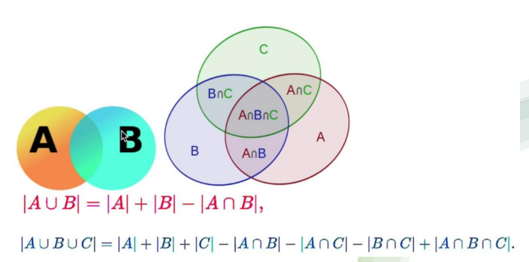
^note: PLUS |AnBnC|

Permutations: counting of distinct objects in an ordered arrangement, i.e. 1,2,3 is different to 3,2,1. An ordered arrangement of r elements is an r-permutation.
Number of r-permutations of a set of n distinct elements is:

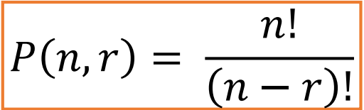
For sets consisting of indistinguishable objects, e.g. two 1s:

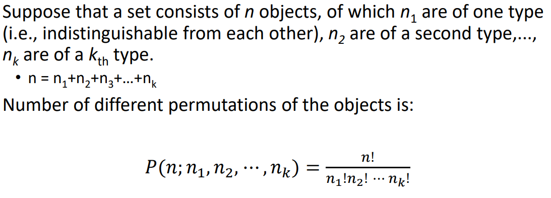
Combinations: counting of distinct objects in an unordered arrangement, i.e. 1,2,3 is the same combination as 3,2,1. Unordered arrangement of r elements is an r-combination.
Number of r-combinations of a set with n distinct elements is
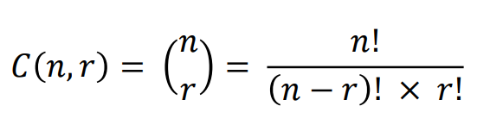
Set Theory:
A set is a collection of unordered objects.

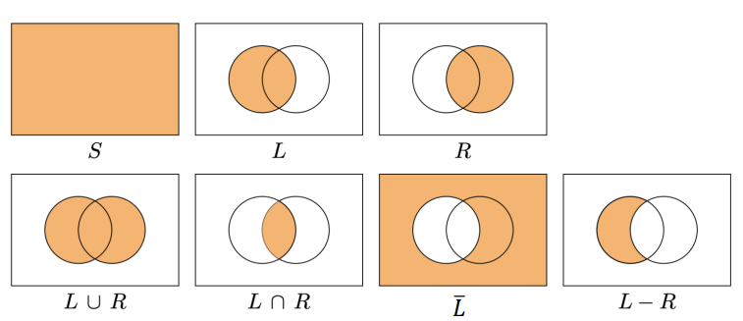
Probability: formalisation of uncertain events, allows us to infer probabilities based on assumptions and observations.
Statistics: Practice of collecting and analysing data and extracting knowledge from data.

An experiment is a procedure that yields one of a given set of possible outcomes, e.g. heads or tails.
The sample space is the set of possible outcomes, and an event (outcome) is a subset of the sample space.
For a finite sample space S, then the probability of an event E occurring is:
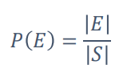
Where E is a subset of S.
P(S) = 1, P(E) is always between 0 and 1 inclusive
For independent events (with no intersection):
Other derived rules:
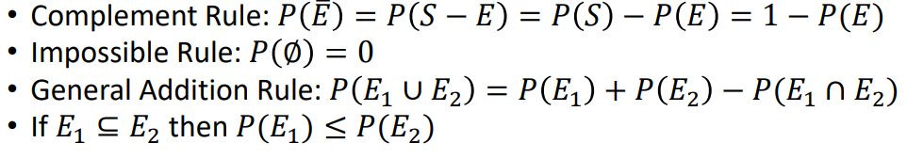
For Multiple events:
Event A occurs with probability P(A) = |A| / |S|, i.e. the number of outcomes where A occurs divided by the total number of outcomes in the sample space.
Basics:

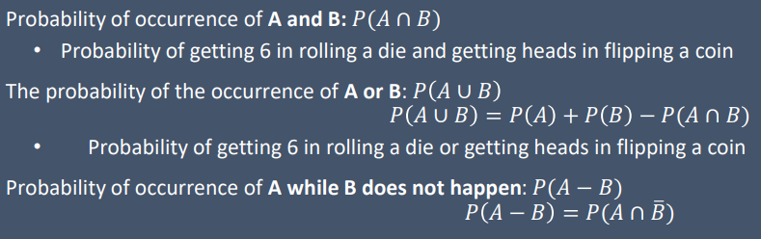
Events can happen concurrently, after each other or because of each other. Depending on the nature of the relationship between events, the probability of each event can be calculated based on other events.

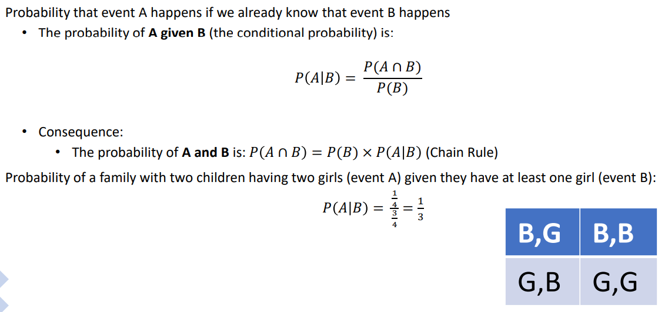
Conditional probability:
Dependence and Independence:
- Events can occur independently, i.e one is not dependent on another
- Two events are independent iff P(AnB) = P(A) * P(B)
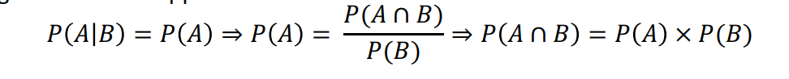
- i.e. if two events A and B are independent, the probability of A will not affect the probability of B, i.e.
- If P(A|B) = P(A), then A and B are independent.
Mutually exclusive events are always DEPENDENT – if we already know one event has happened we know the other has not.

Bayes’ Theorem:

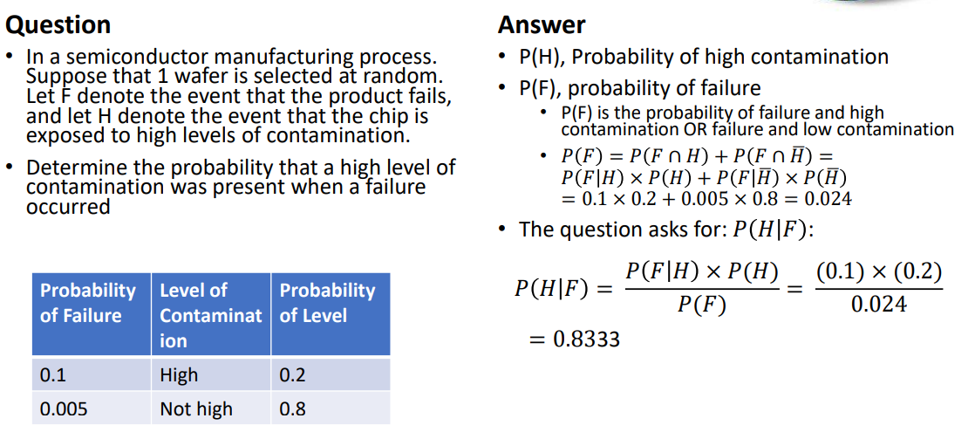
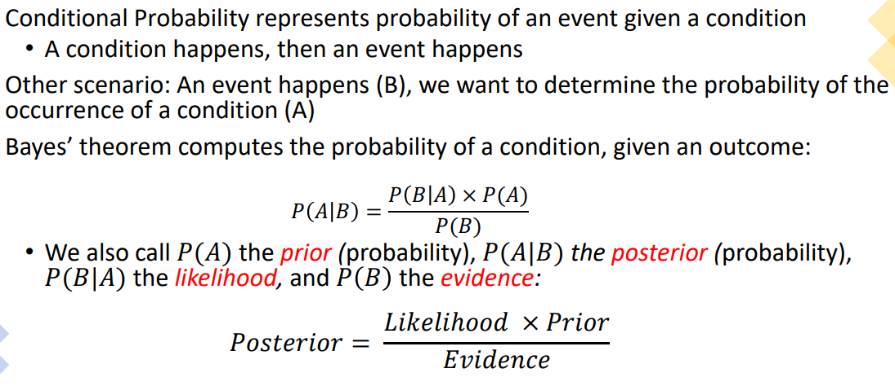
Example:
Suppose events E1, E2, … , En are mutually exclusive events, such that
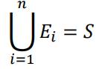
i.e. Exactly one of the events must occur.
If A is any event, then the probability of one of the events Ek occurring given A occurred is given by:
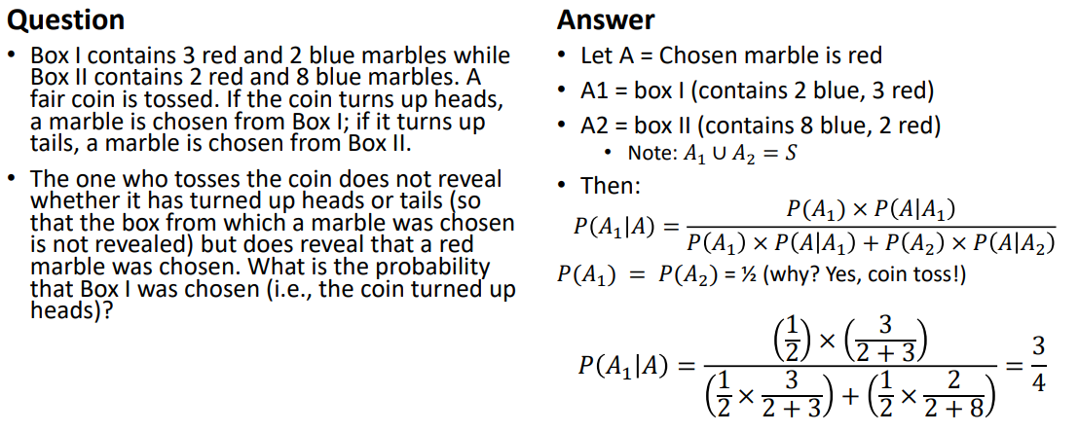
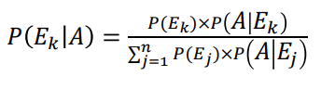
Example:

Discrete Probability Distributions
A random variable is a function that assigns a number to each outcome in the sample space of a random experiment, usually denoted by a capital letter. A random variable is discrete if it can take a finite number of different values, or a countably infinite set of values.
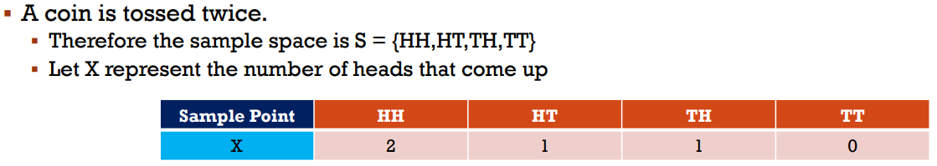
Example:
Many real world situations can be modelled using discrete random variables.
The probability distribution of a random variable X describes the probabilities associated with each possible outcome of X.
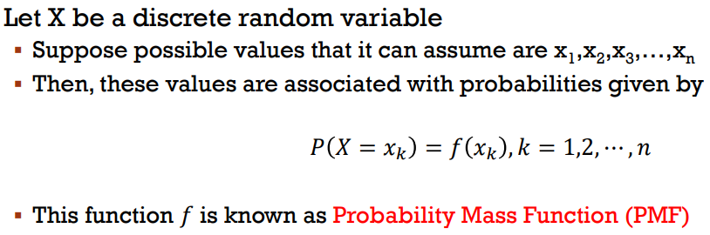
The value of this function is a probability, i.e.
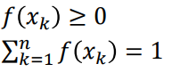
Mathematical definition:

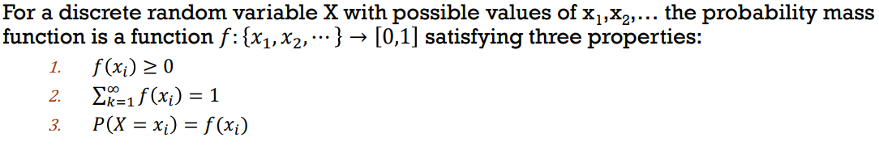
PMFs can be plotted as graphs:

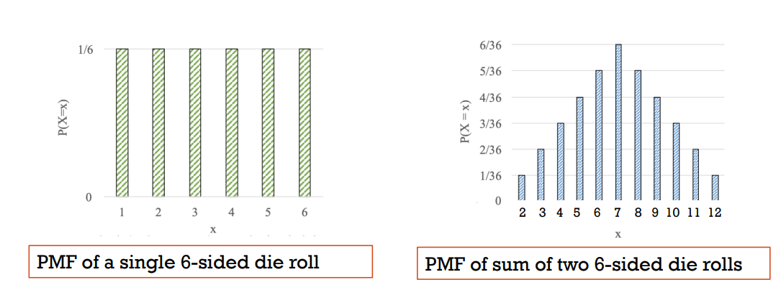
To compute a PMF:
- Collect all possible outcomes where X = x
- Add their probabilities
- Repeat for all x
Example:
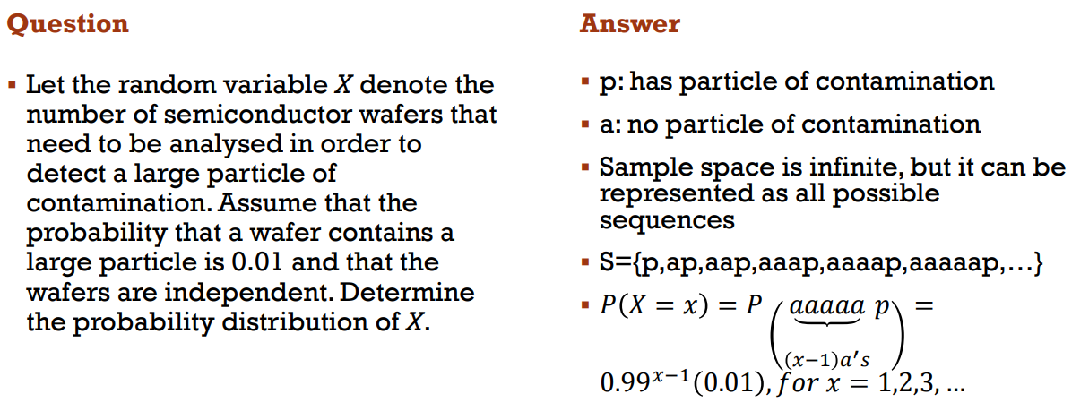
^ probability for x = 1 is 0.01 hence the (0.01)

Cumulative distribution function CDF:
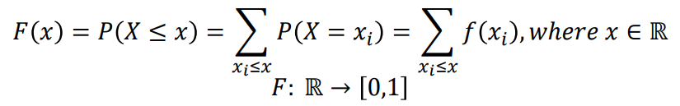
(we usually work with PMF for discrete random variables)
Properties:
- F(x) is nondecreasing
- Limit of F(x) is 0 at -infinity and 1 at +infinity
PMF is restricted to the values of X but CDF can take any real number as a value.
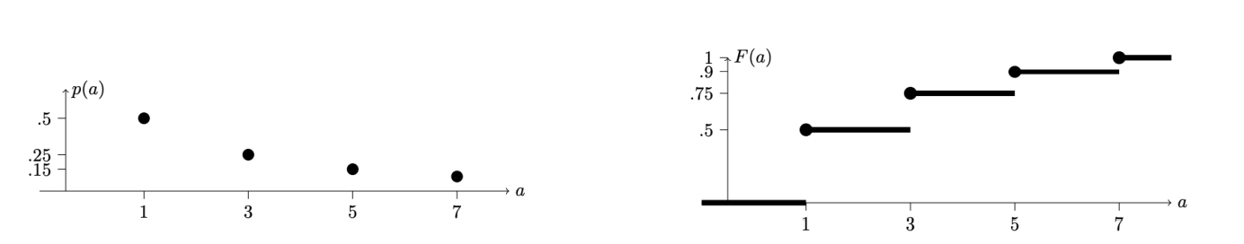

Mean and Variance are used to summarise a probability distribution of a random variable X:
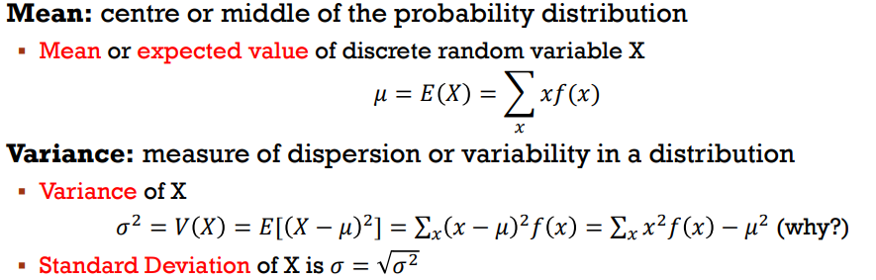
^f(x) is the PMF of x. mu² is not in the sum for the last variance definition.

Functions of random variables are also random variables.
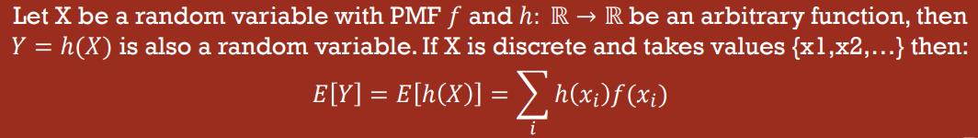
Properties of random variables:
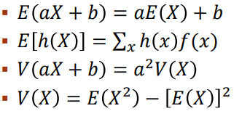
Where X is a random variable and E() is the mean and V() is the variance.
Note: E(X²) != E(X)²
E(X) can be called the first moment (why??) and E(X²) is the second moment. V(X) is the central second moment.

Two random variables X and Y are independent if for any sets A and B:
If random variables are independent, the variances always add up:
V(𝑋1 + 𝑋2 + ⋯ + 𝑋𝑛) = 𝑉(𝑋1) + 𝑉(𝑋2) + ⋯ + 𝑉(𝑋n)

The mean/expectations add up regardless of whether random variables are independent or not:
𝐸 (𝑋1 + 𝑋2 + ⋯ + 𝑋𝑛) = 𝐸 (𝑋1) + 𝐸 (𝑋2) + ⋯ + 𝐸(𝑋𝑛)

Special Discrete Distributions:
Discrete Uniform Distribution:

The probability for each x is the same.
For X being a discrete uniform random variable on the consecutive integers from a to b:

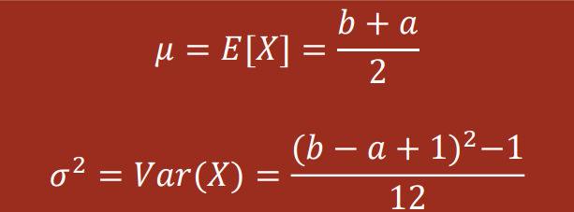
Bernoulli Distribution:
An outcome consisting of two possibilities, e.g. a pass and a fail.
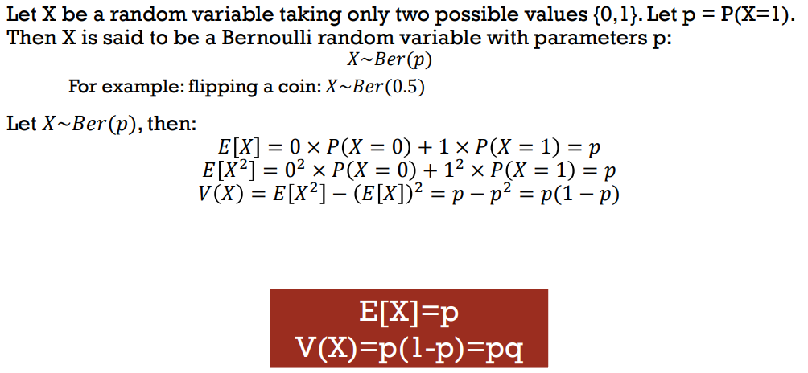
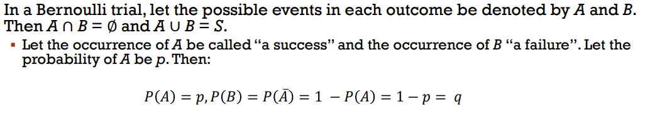
^i.e. every outcome is either a success or a failure, never both, and never neither.
^ this is a binomial distribution with n=1. P is the probability of success.

Binomial Distribution:
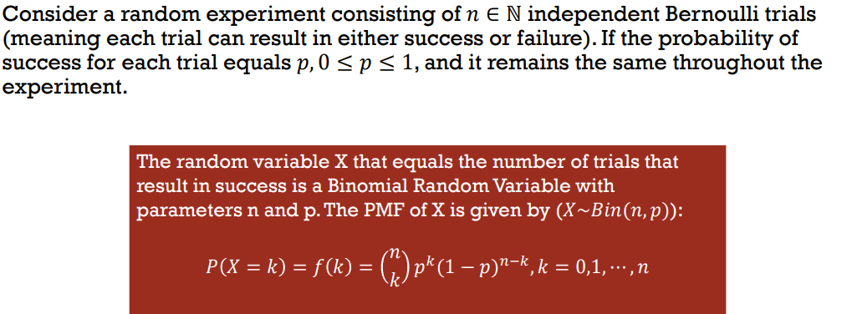
^ now we have n and p, where n is the number of trials and p is the p from the Bernoulli trial.

Since all the n trials are independent, we can sum the variances and expectations to get the overall variance and expectation:

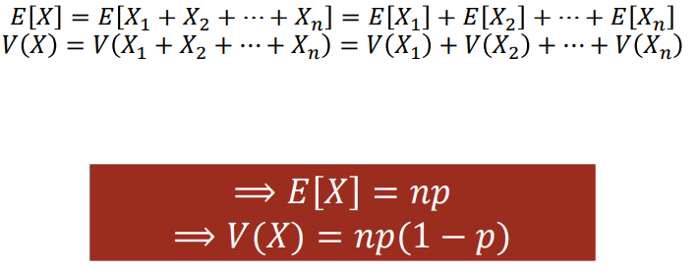
Pretty pictures:

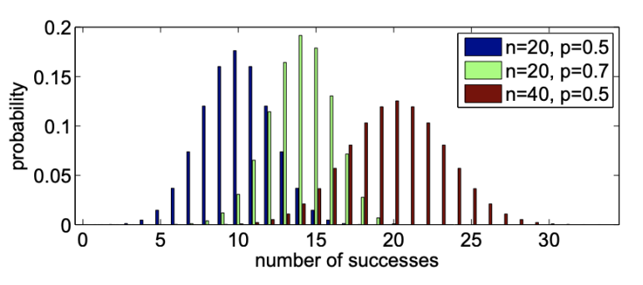
Geometric Distribution:
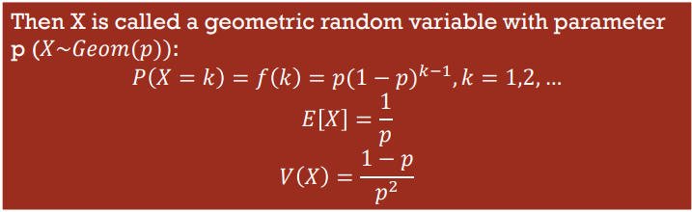
Random variable X is the number of independent Bernoulli trials needed to get the first success.
The geometric distribution is memoryless – no matter how many failed trials you have made, the probability that you have to wait m more trials to get a success is the same as the probability of getting the first success after the first m trials. i.e. the number of previous failures does not impact the probability of the number of further trials needed to get to a success.
The geometric distribution is the only distribution that has this property.

Negative Binomial Distribution:
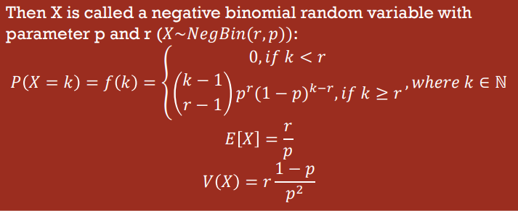
Performing a series of independent Bernoulli trials until we reach n successes.

Example:

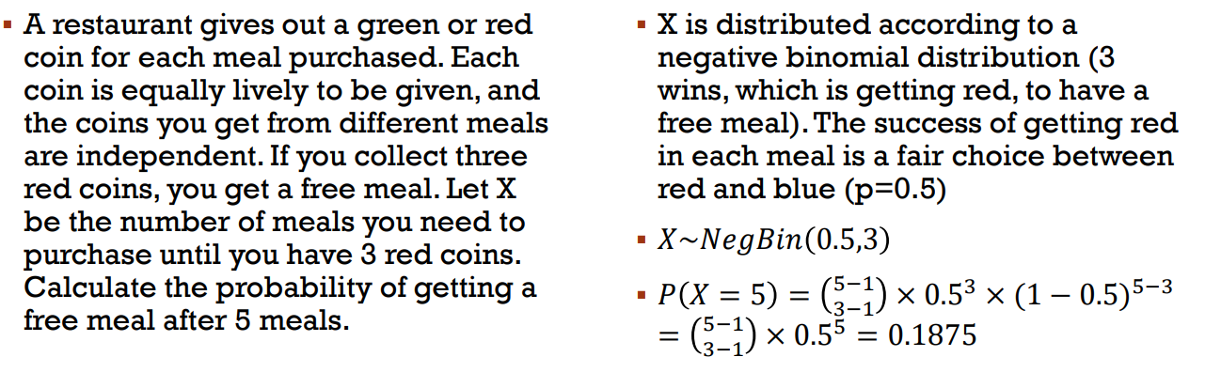
Poisson Fish Distribution:
- Important and useful, e.g. in the study of queues
- Is derived from the binomial distribution.
Suppose you want to model the number of customers entering a shop over the period of one day, assuming:
- Customers behave independently of each other
- The expected number of customers per unit time is constant, e.g. lambda = 12 means 12 customers per day. Dividing the day into 24 intervals, i.e. with n=24, we get 0.5 customers per interval.
- If the intervals were reaaaaally small, the number of customers are either 0 or 1 with very high probability. The number of customers in each interval is approximately a Bernoulli random variable with p = lambda / n , and they are also independent.
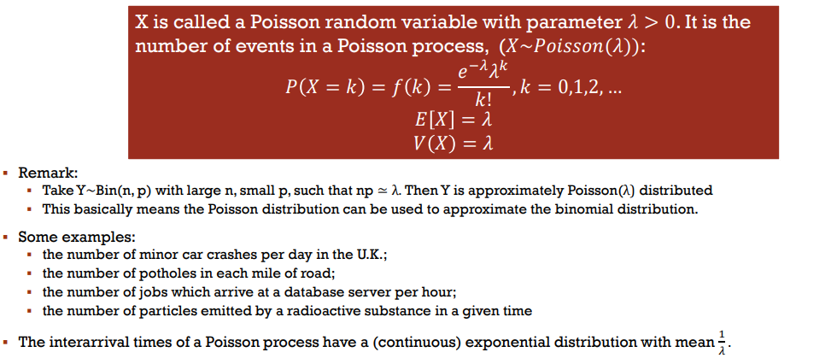
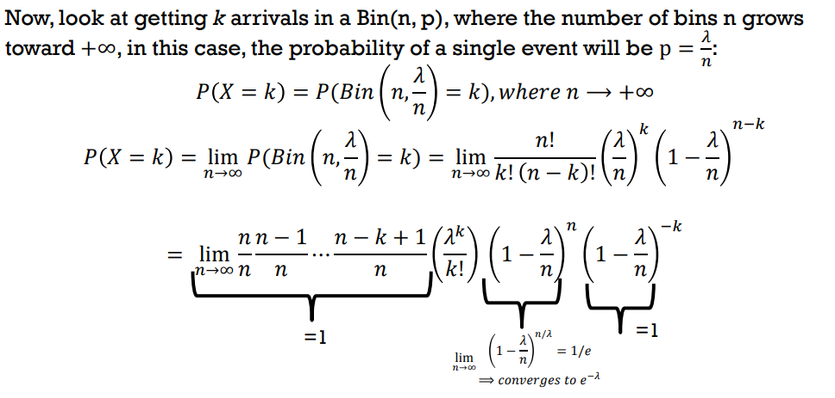
(goddamn where’s Tufty when you need him)

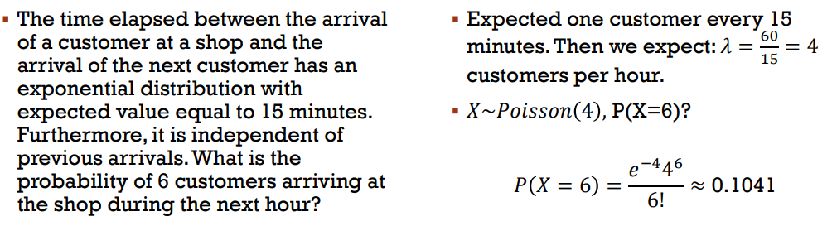
Example:

Continuous Random Variables:
Let X be a random variable representing temperature.
P(X <= 3000) = 1
P (10 <= X <= 30) = 0.63
But we cannot determine the probability of a specific value, so it is always 0
- This is because there are uncountably many possible values within any interval.

Probability Density Function (PDF):
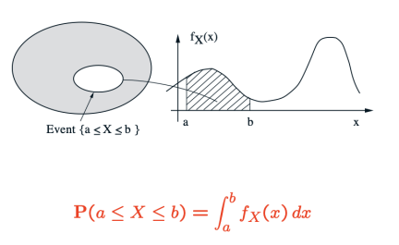
A continuous random variable is described by a PDF:

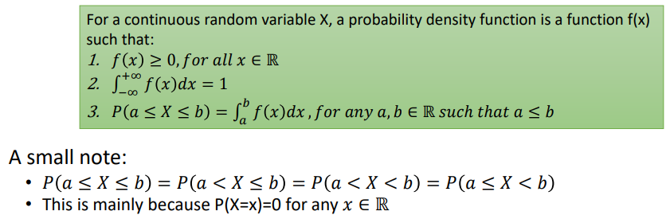
The PDF of X is denoted by f_{x} or f

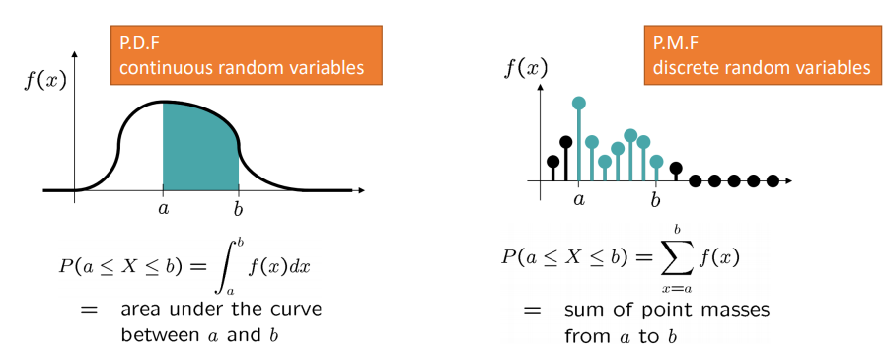
Continuous vs Discrete random variables:

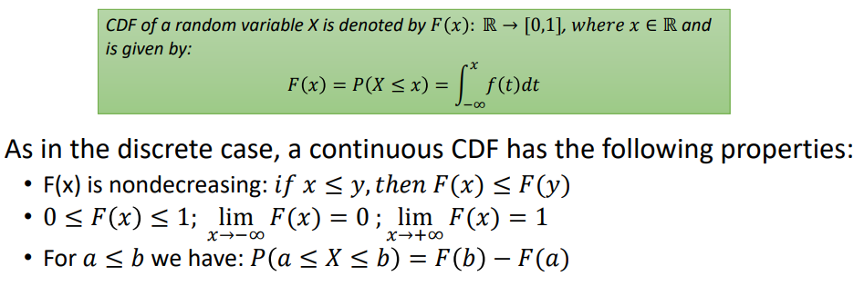
Cumulative Distribution Function (CDF), F(x):
Note: the derivative of F(x) is f(x), i.e. the PDF is the derivative of the CDF.
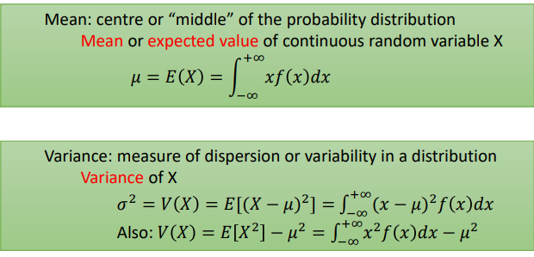
Mean and Variance are values used to summarise the distribution:

The output of a function on a random variable is also a random variable.
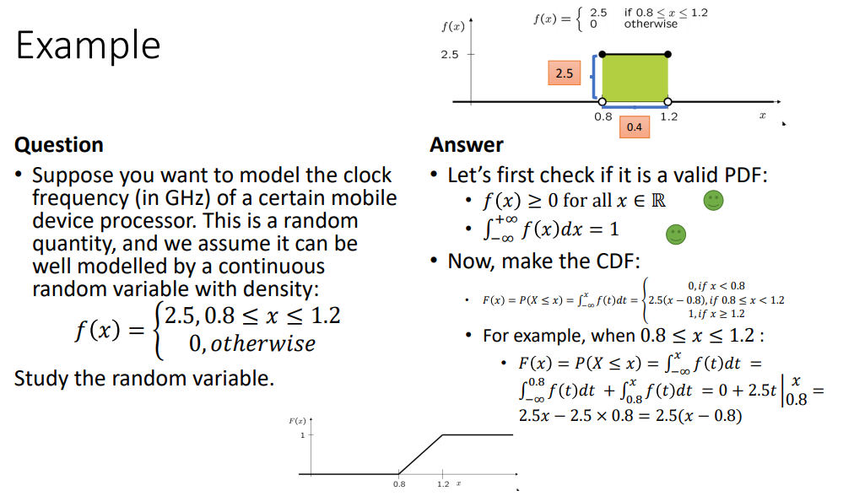

Mean and Variance properties are as with Discrete random variables, i.e.:
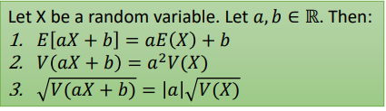
Example:

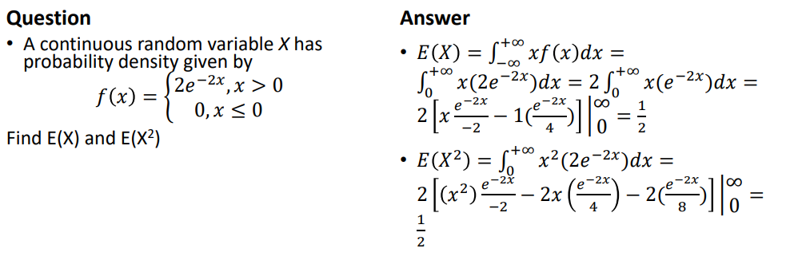
Continuous Uniform Distribution:
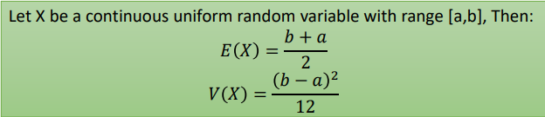
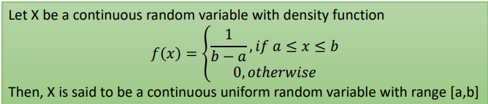
i.e. every interval of the same size has the same probability; the probability is uniformly distributed.

Exponential Distribution:
- Is memoryless
- Often used to model the time elapsing between events
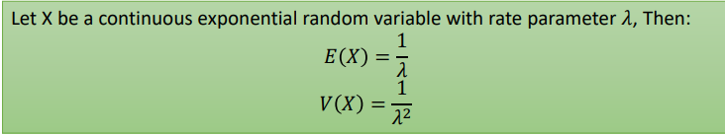
- Has a parameter λ called the rate parameter, which is the average number of events occurring in one unit of time.
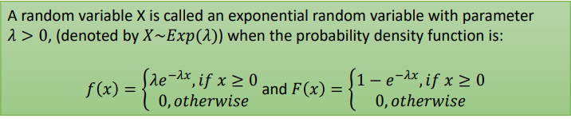
Applications of the exponential distribution include:
- Amount of time until an earthquake occurs
- Length of telephone calls
- Time until a device fails
Memorylessness:
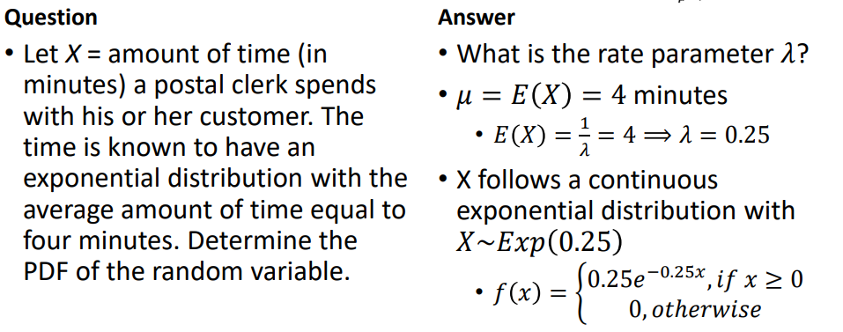
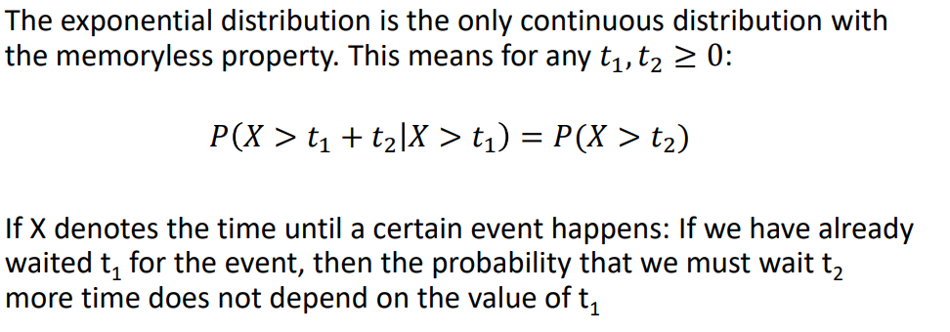
Example:
^(using mu to find lambda)

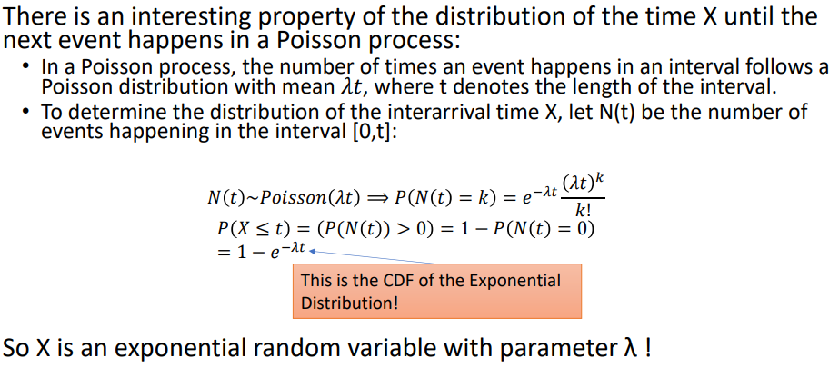
Exponential with Poisson Process:

Normal Distribution: probably the most important continuous distribution.
The sum of many independent random variables almost always looks like a bell curve. This curve can have a different centre (mean, mu) and spread (variance, sigma²).
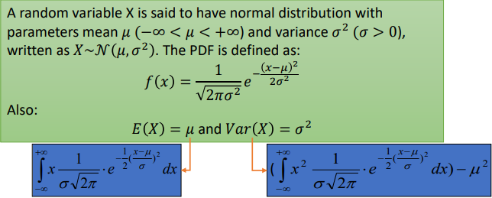
^remember for continuous random variables, the mean is given by the integral of x*f(x)dx, and the variance is given by the integral of x²f(x)dx minus mu²

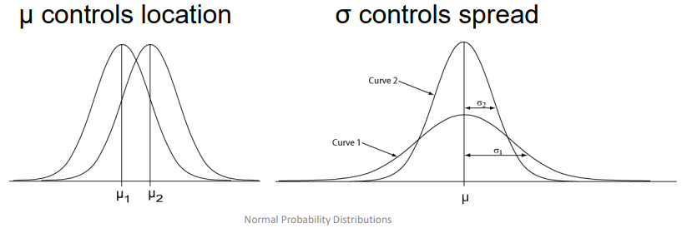
Properties of Normal Distribution:
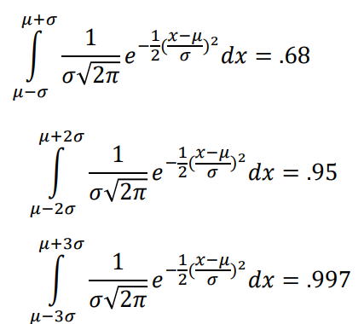
- Regardless of mean and standard deviation, the area between μ-σ and μ+σ is about 68%
- Regardless of mean and standard deviation, the area between μ-2σ and μ+2σ is about 95%
- Regardless of mean and standard deviation, the area between μ-3σ and μ+3σ is about 99.7%
- i.e. almost all values fall within 3 standard deviations of the mean.
- Using symmetry we can get other properties, i.e. the area between 0 and μ+σ is about 34%
Example:
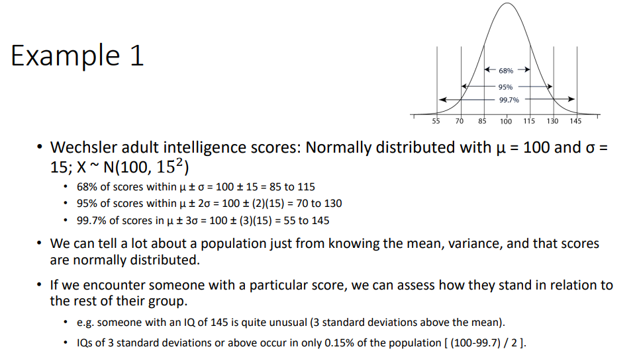

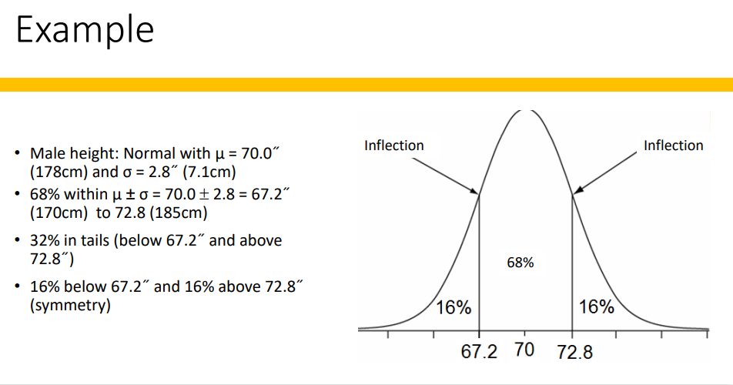
Standard Normal Distribution:
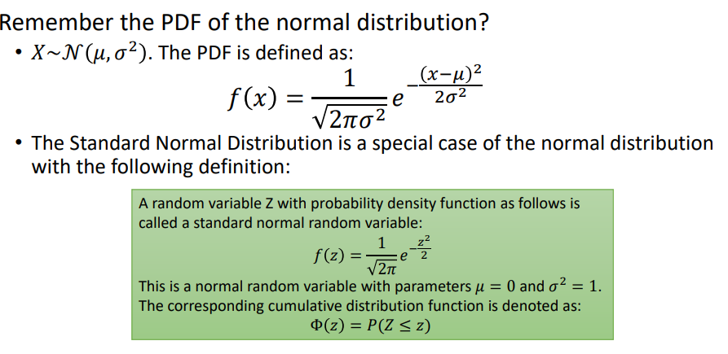
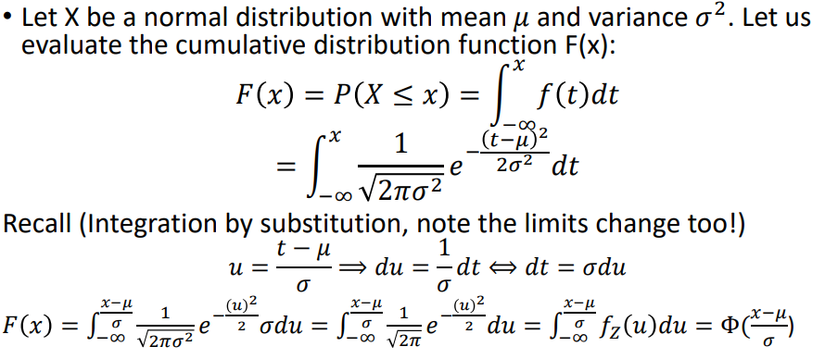
^ i.e. F(x) = P(X <= x) = Φ ( (x-μ)/σ ), i.e. z = (x-μ)/σ. All normal distributions X can be converted to the standard normal distribution in this way.
This is the Z score: this tells us how many standard deviations the value of X is above or below the mean. We also have a z-table that has all the values on it to make the math easier.
Z-scores let us use one table for all normal distributions.
Example:

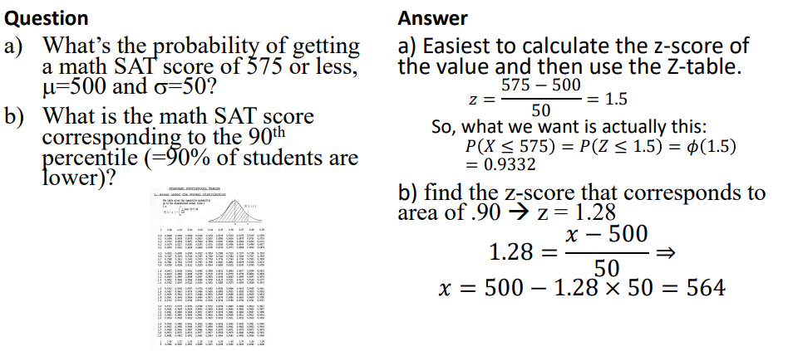
Z tables sometimes only have positive values for z. Since the standard normal PDF is symmetric around 0, then Φ(z) = 1 - Φ(-z)
Example with conditional probability:

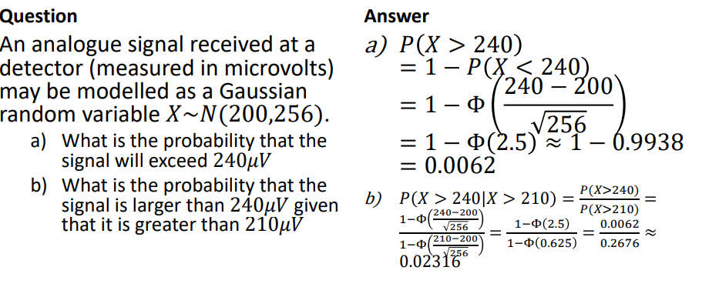
The Normal distribution can also be used to approximate the binomial distribution.

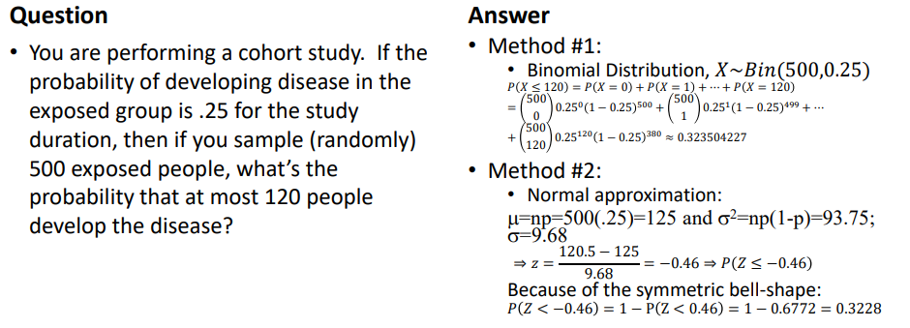
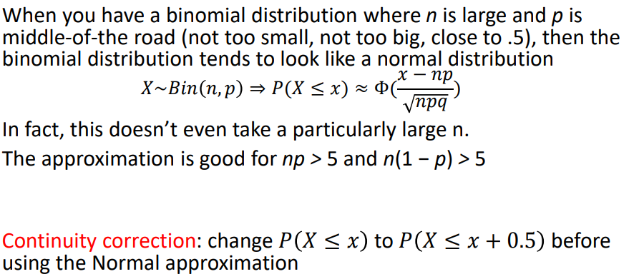
Example:
^one of these methods is much nicer than the other
Note: approximate mu = np, sigma²=np(1-p) where n and p are the values for the Binomial, and mu and sigma² are the mean and variance used in the normal approximation if using non-standard normal, otherwise use formula above.

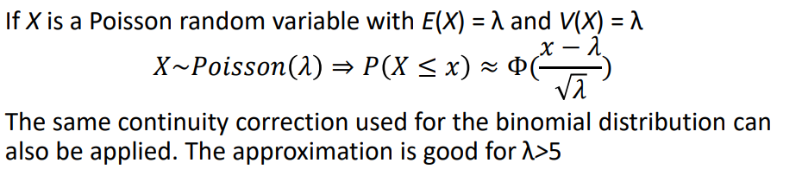
The normal distribution can also approximate the Poisson distribution.

Example:

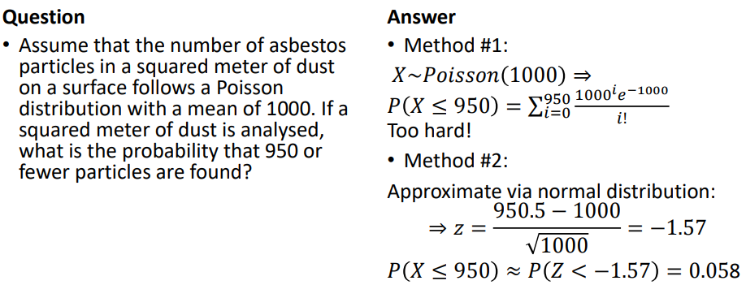
Note: continuity correction used for x = 950 in the calculation of the z-value.

Multiple Variables:
Most real world problems involve multiple random variables.
Join distributions allow us to reason about the relationship between multiple random events. Distributions with 2 variables are Bivariate, more than 2 = multivariate.
Bivariate Distributions:
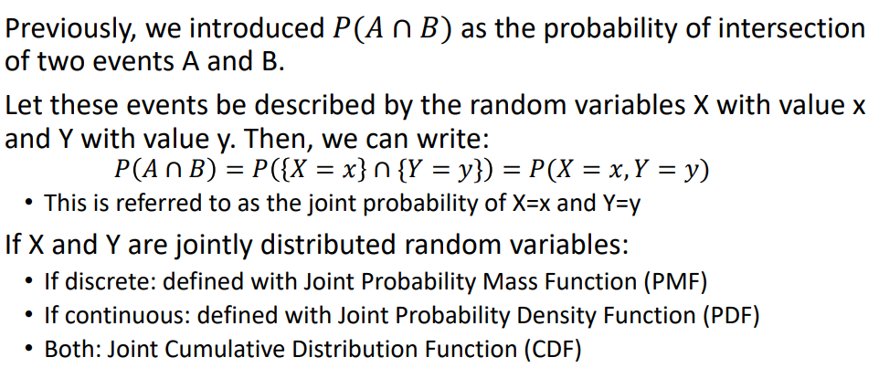
The PMF of a single discrete random variable specifies how much probability is placed on each possible value.
A joint PMF describes how much probabilitiy is placed on each possible pair of values (x,y) from the two variables X and Y.

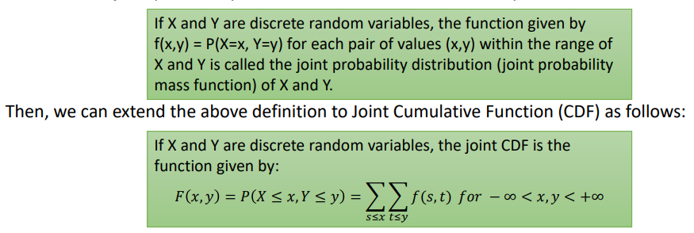
Properties similar to regular PMF:

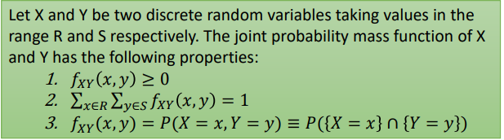
Marginal Probability Distributions: considering an individual variable separately from a bivariate distribution.
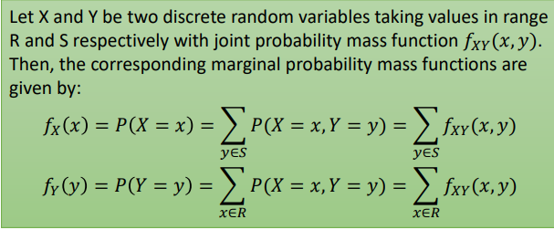
^i.e. to find P(X=x) add up the probabilities of all combinations where X=x.
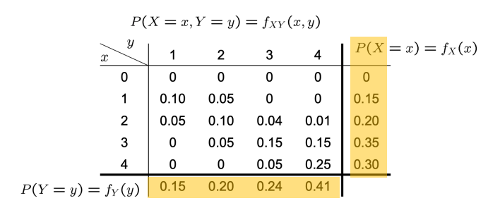
e.g.:
Conditional distributions: finding the probability of X given a value of Y and v.v.
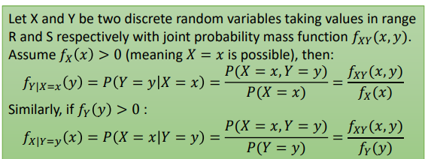

E.g.:
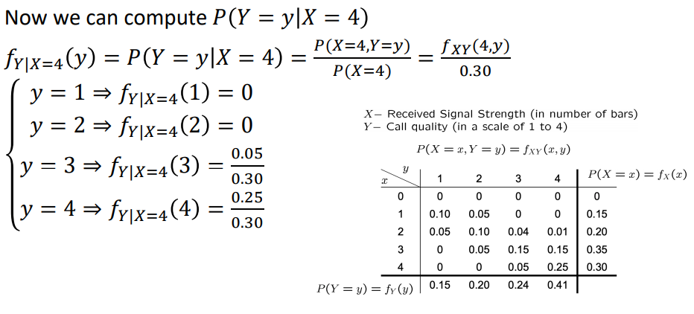
^this is the probability distribution for Y given that X = 4.
Conditional PMFs also exist, with similar properties for normal PMFs:

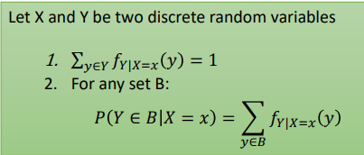
Note: we never consider conditional events P(X=x | Y=y) when P(Y=y) has probability 0.

Continuous Bivariate Random Variables:
Joint PDF:

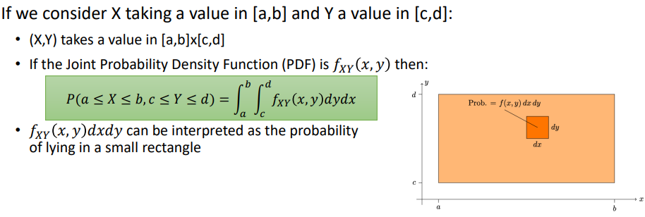
Properties:

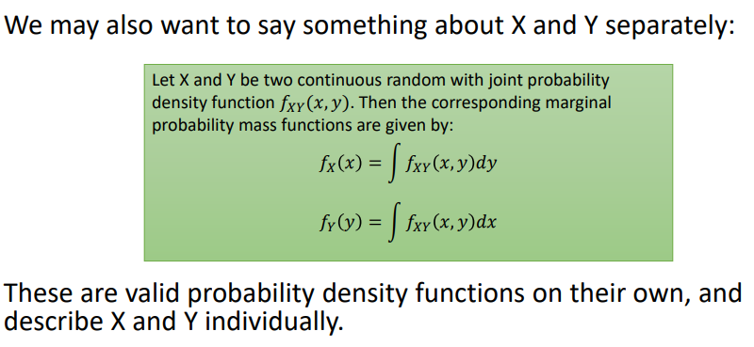
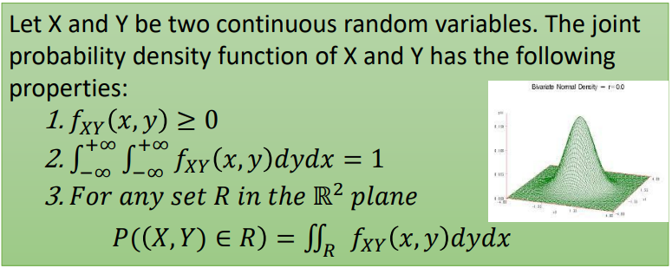
Continuous Marginal Probability Distributions:
Continuous Conditional Probability Distributions:
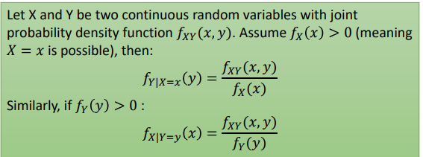
^ note the condition has to have probability > 0 because divide by zero = bad
Properties: same as normal PDF
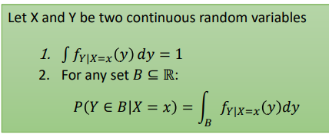
Multivariate Continuous Distribution:

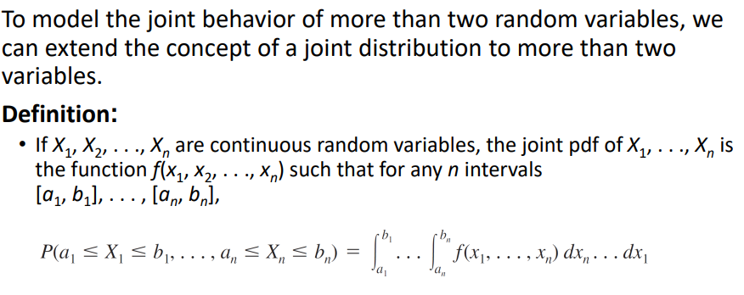
Marginal distributions for more than 2 variables: integrate out all other variables, e.g.:

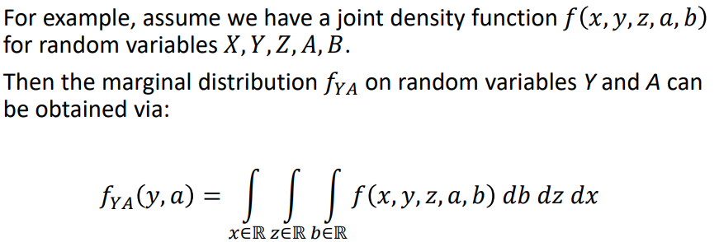
^integrate wrt the garbage variables we don’t want to get the joint distribution of the variables we do want.
Independence of random variables, i.e. the value of one does not change the value of the other:
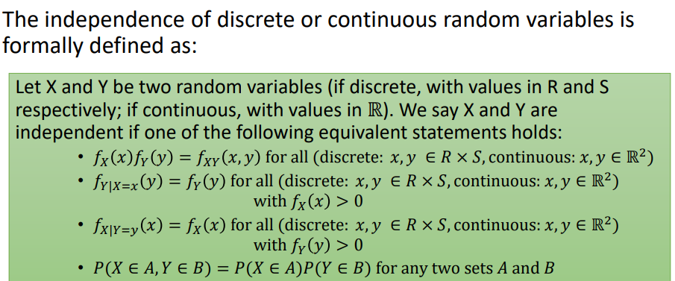
^if any of these conditions are violated, the variables are not independent.
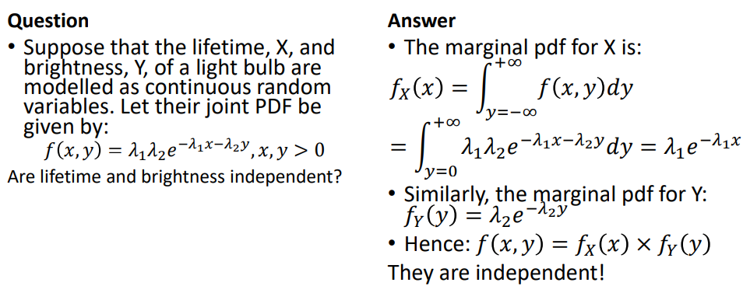
Example:
^independent since f_{X}(x) (marginal distribution for x) * f_{Y}(y) = f_{XY}(x,y) (the joint PDF).
Mean and Variance for joint random variables:

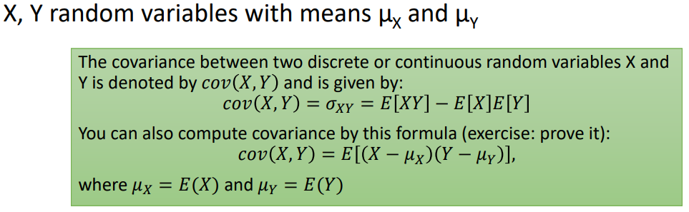
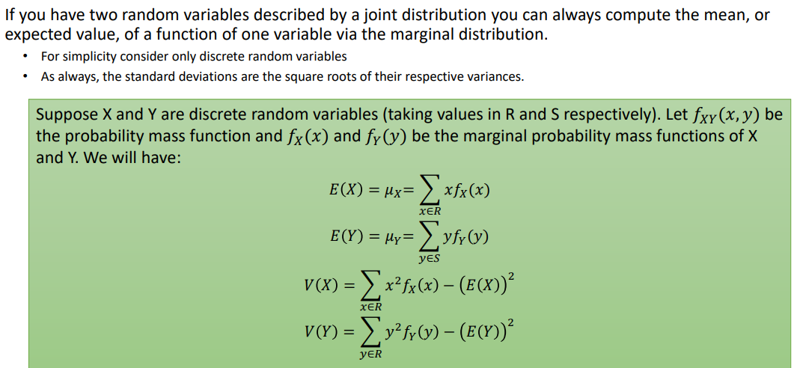
Covariance: Measuring how closely associated multiple variables are, i.e. measures the strength of the linear relationship between them.
What the sigma
Properties of Mean and Variance:
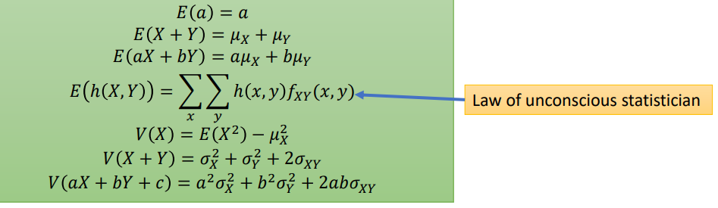
^the statistician deserved to be made unconscious for choosing to become a statistician. Also why do we use the same symbol for variance and covariance
σ_{X}² is the variance of X, σ_{XY} is the covariance of XY.

Properties of covariance:

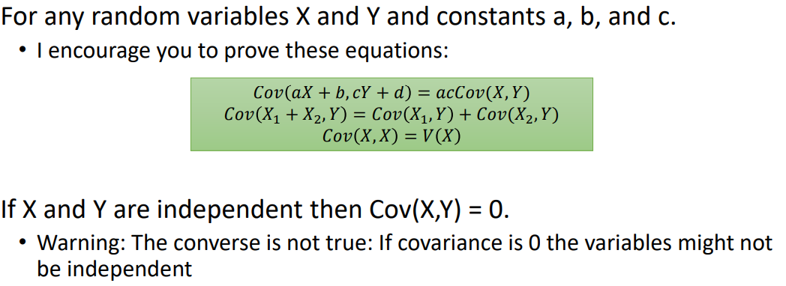
We can use the covariance to calculate the correlation coefficient:
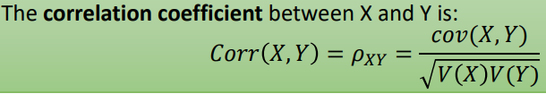
This coefficient lies between -1 and 1. p_{XY} only equals 1 if Y=aX+b for some a>0, and pXY only equals 1 if Y=aX+b for some a<0. If variables are independent, the coefficient is zero, but if the coefficient is zero that doesn’t strictly mean the variables are independent.

Statistics:
A population is a group that includes all individuals or cases we are interested in. A sample is a relatively small subset of the population, usually randomly chosen.
We can observe features of a sample – statistics – to gain information about the features of the population – parameters. Every statistic is a random variable, and cannot be expected to give the exact value of the parameter, as the sample is randomly chosen.
Note: Parameter = Population, Statistic = Sample.
The Greek letters mu and sigma are used for the mean and standard deviation of the whole population, while $\overline{x}$ and s are used for the mean and s.d of a sample.
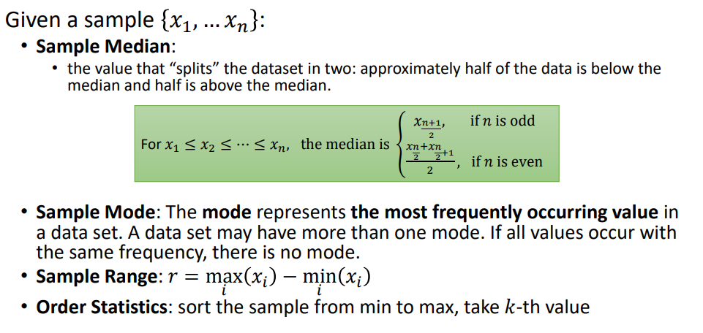
^ if you’re in Durham and you don’t know what a median is then you got issues
Note: the population distribution describes the individuals making up a population, a sampling distribution describes how a statistic varies across many samples.a

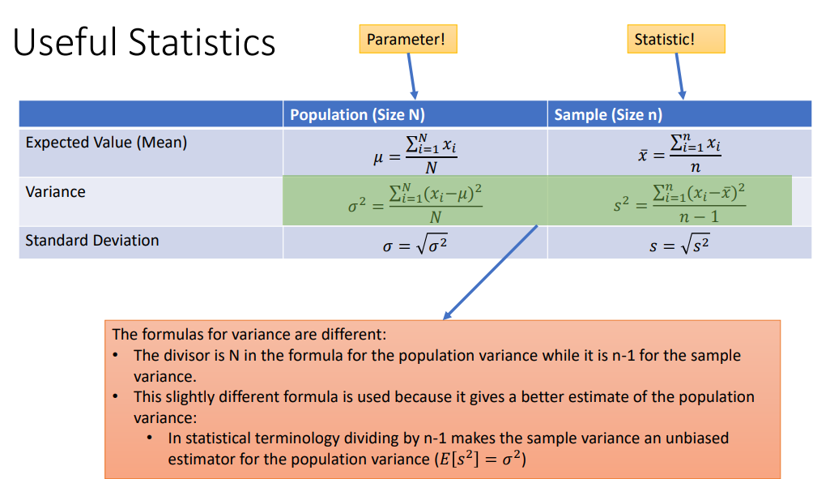
We can use statistical inference to use information about a sample to draw conclusions about a population.

Inequalities and Bounds:
These allow us to say something about the probability distribution based off of the mean and variance.

Markov’s Inequality:
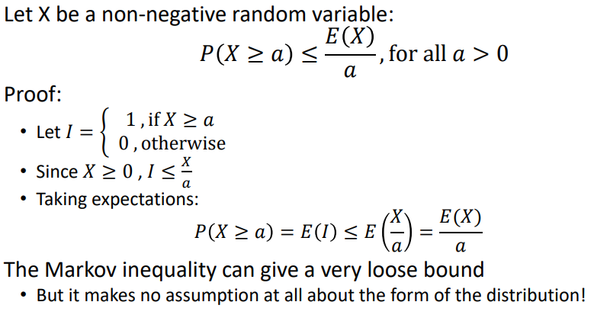
Chebyshev’s Inequality:
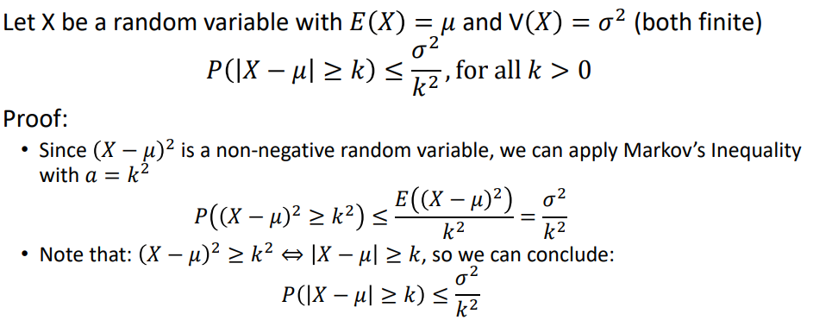

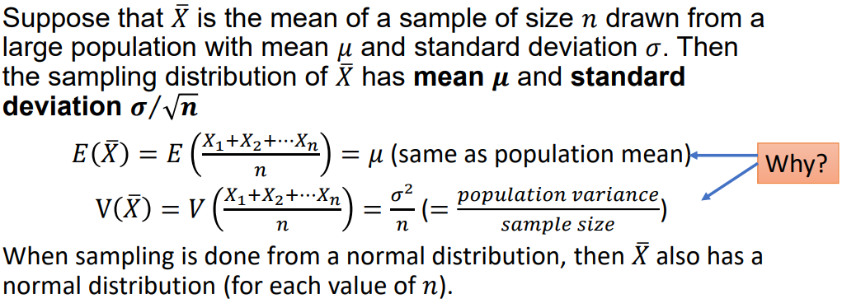
Distribution of Sample Mean:

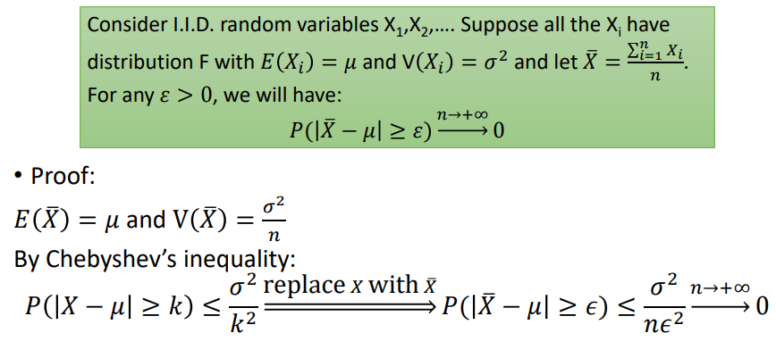
Weak Law of Large Numbers:
Strong Law of Large Numbers:
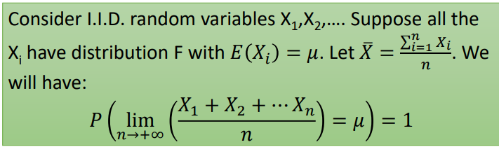
Note: I.I.D = Independent and Independently Distributed.
The strong law says that taking infinitely many samples results in the population mean.

Central Limit Theorem:
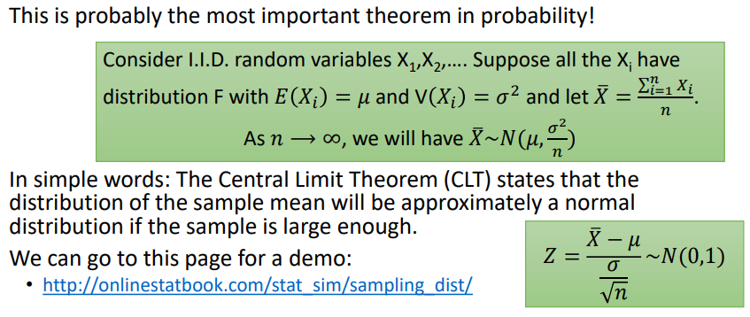
i.e. a large enough number of samples will produce a normal distribution of the sample means, with sufficiently large sample size (i.e. sample size of 1 or 2 will not produce this distribution). A sample size of 25-40 is generally sufficient.
CLT explains why many things in the real world follow normal distribution.
Example:
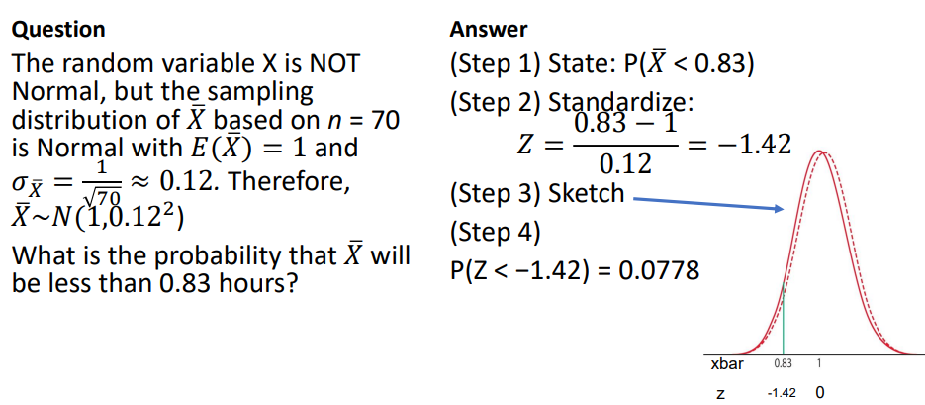

Statistical Inference:
Recall: Sample is a random subset of the overall Population. Populations have parameters, which are constants and cannot be directly calculated. We can use Statistics based off the sample to estimate the parameters of the population, but these statistics are not constant since they depend on the sample.
Central Limit Theorem: given a large enough sample size, then the distribution of the Sample Mean will be approximately Normally distributed:
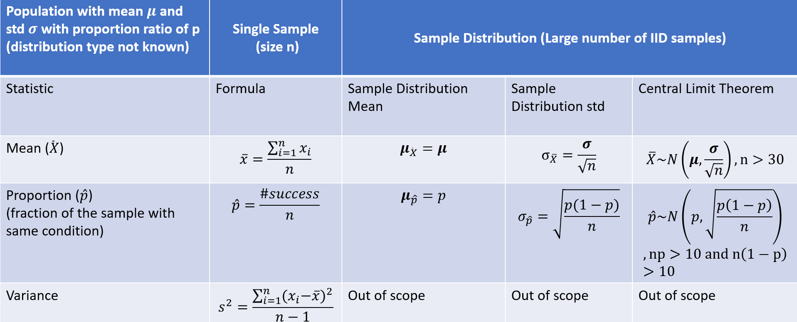
Summary:

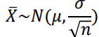
The standard error of a sample statistic is the standard deviation.
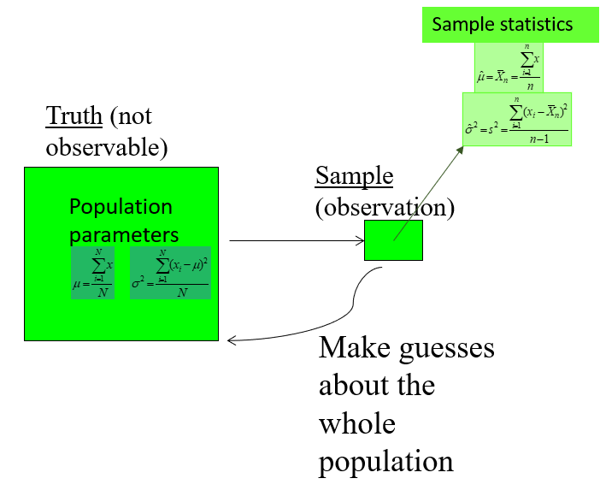
Statistical inference is the process of making estimates about the population based on a sample.

Types of Statistical Inference:

- Hypothesis testing (oh fuck)
- Estimating population parameters

A point estimator draws inference about a population by estimating the value of a parameter based on a single point, e.g. using sample mean to estimate population mean.
Bias and Variance of Estimators:

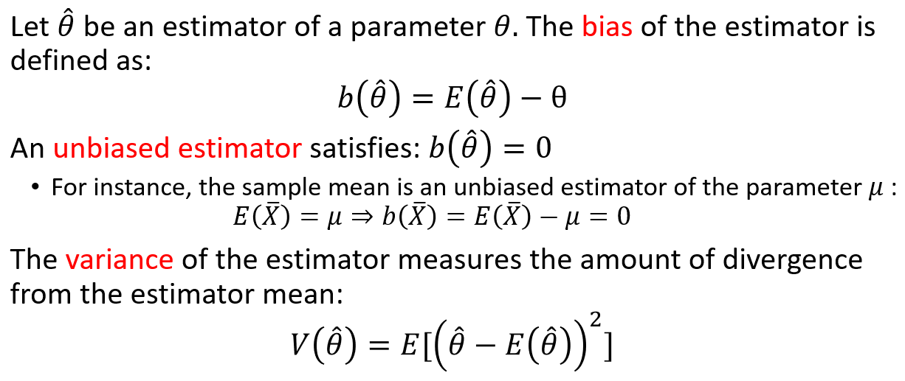
Interval Estimator: like point estimators but estimating an interval of values for the population parameter rather than estimating an exact value for the parameter. This interval will be more likely to contain the correct value of the parameter.
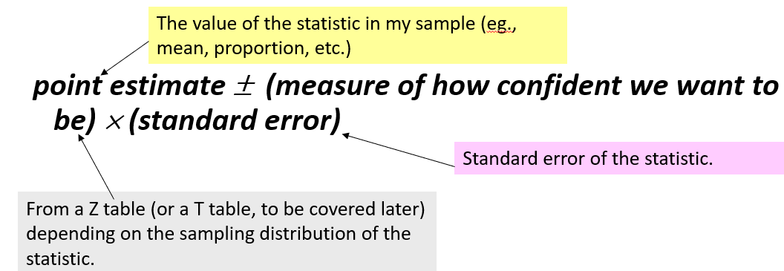
Confidence interval: A plausible range of values for a population parameter. A 95% confidence interval means that the interval will contain the true value 95% of the time, depending on the sample. It does NOT mean that there is a 95% chance of the correct answer being within an interval.
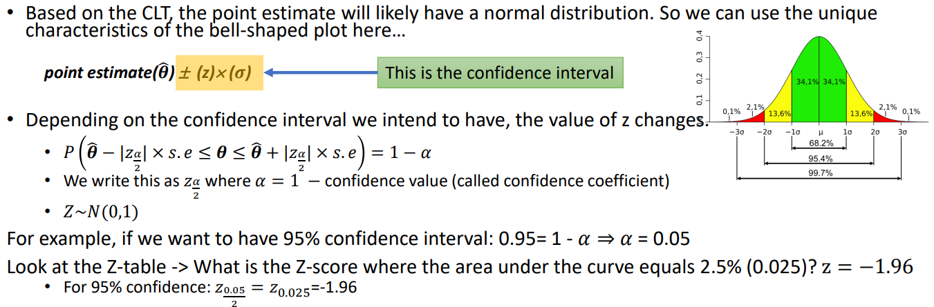
^take the percentage, subtract it from 1 and divide the result by 2. Find the z-value for this number and multiply by standard deviation to get the confidence interval.

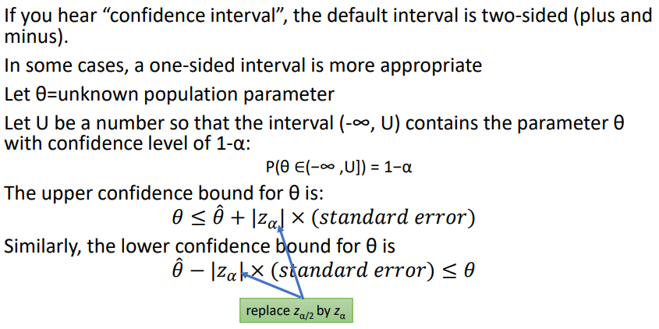
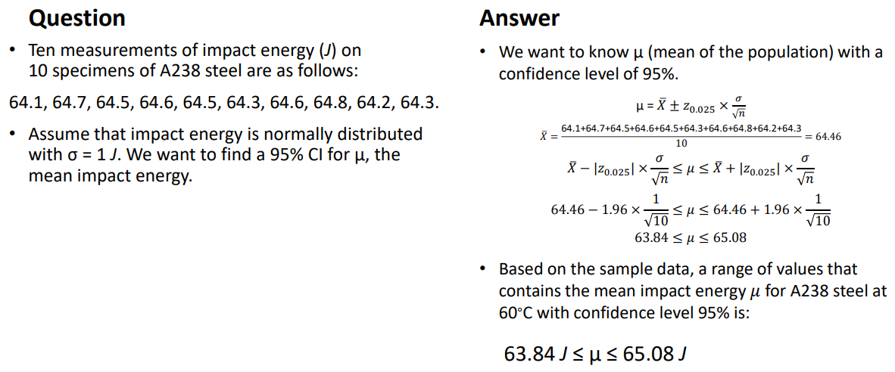
Example:
^i.e. don’t divide by 2 for one-sided interval, otherwise same process.

Hypothesis Testing:
A statistical method that uses sample data to evaluate a hypothesis. It involves a hypothesis and a process to determine whether or not we should reject the hypothesis.
A hypothesis is an assumption about the population parameter.

Null hypothesis: the assumption to be tested. States there is no difference between a parameter and a specific value.
Alternative hypothesis: States a difference between a parameter and the specific value, often the opposite of the null hypothesis.
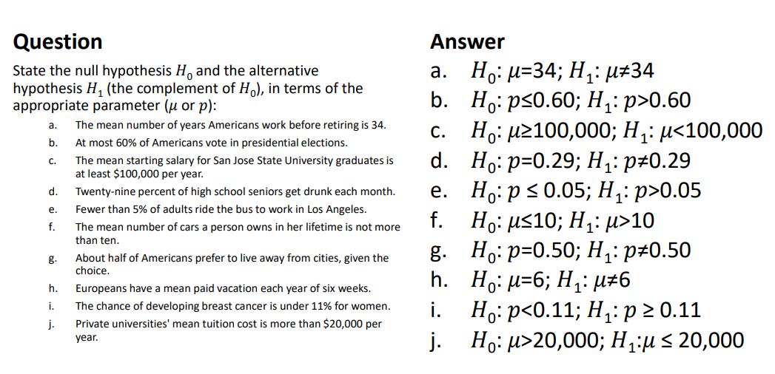
^parameter could be mu or p; hypotheses can be equalities, inequalities or < <= => >.
Hypothesis Testing:
- Assume H0 and H1
- Take a random sample and take the sample statistic
- Calculate the probability that the sample statistic of a random sample is <=/>= the sample statistic under the assumption that H0 is true. This is the p-value.
- If the p-value is smaller than the Significance Level, then reject H0 in favour of H1.
- Otherwise, there is insufficient evidence to reject H0

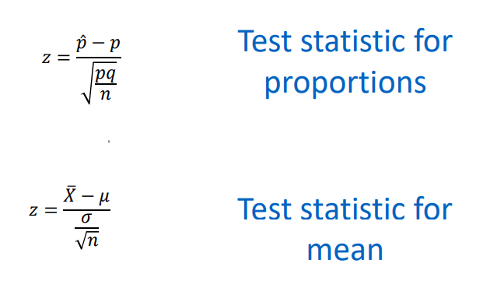
Test statistics for Normal Distribution:
p is the proportion given by the null hypothesis, p^ is the proportion measured. q = 1-p.
Critical regions: The critical region is the set of all values of the test statistic that cause the null hypothesis to be rejected. The significance level is the probability that the test statistic will fall in the critical region, given that the null hypothesis is actually true. A critical value is any value that separates the critical region from the values of the test statistic that do not lead to rejection of the null hypothesis.
The tails in a distribution are the extreme regions bounded by critical values.
A one tailed test has H1 > … or H1 < …, a two tailed test has H1 != … .
In a two tailed test, the significance level is divided equally between the tails.
The p-value is the probability of getting a value of the test statistic that is at least as extreme as the sample data, assuming the null hypothesis is true. For two tailed tests we multiply p-value by 2 for shits n gigs.

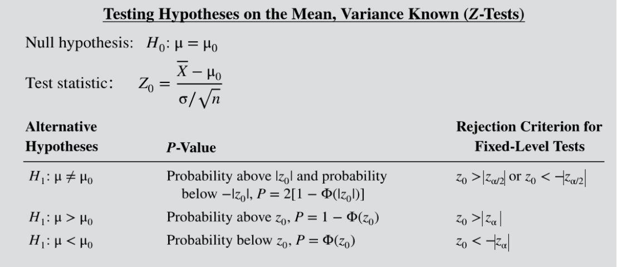
^ We can use this if the population is normally distributed or if n > 30.

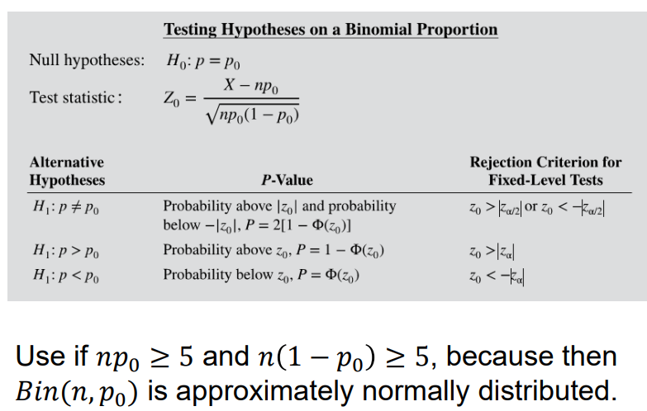
Testing claims about a population when the population Standard Deviation is unknown:
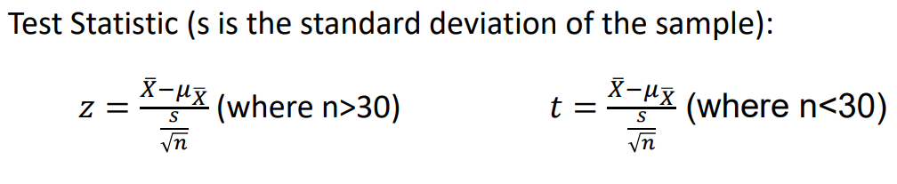
For large sample sizes (n>30) its approximately normally distributed so we can use the sample standard deviations to get the z-value.
Otherwise, we have to use the T-distribution, whose values are given in T-tables.
The t distribution is different for different sample sizes. Has mean of t = 0, with varying s.d. As the sample size gets larger, the t-distribution approaches a normal distribution.

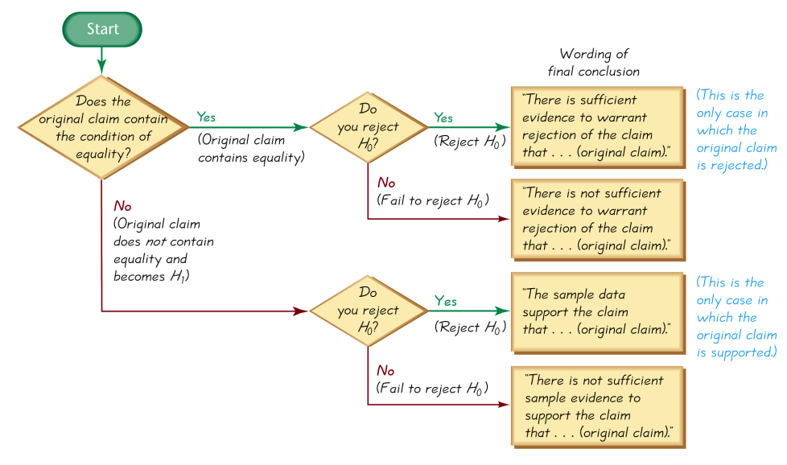
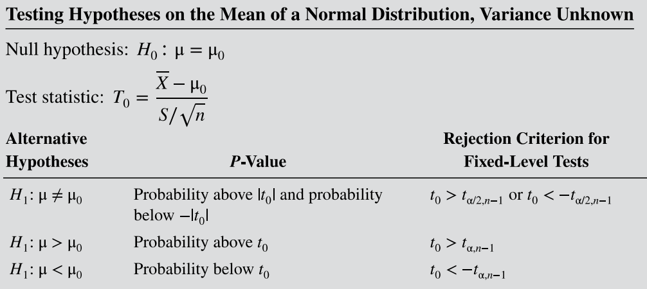
Waffle-o-chart:
Note: do not say ACCEPT the null hypothesis, we just fail to reject it.

Possible errors in a hypothesis test:
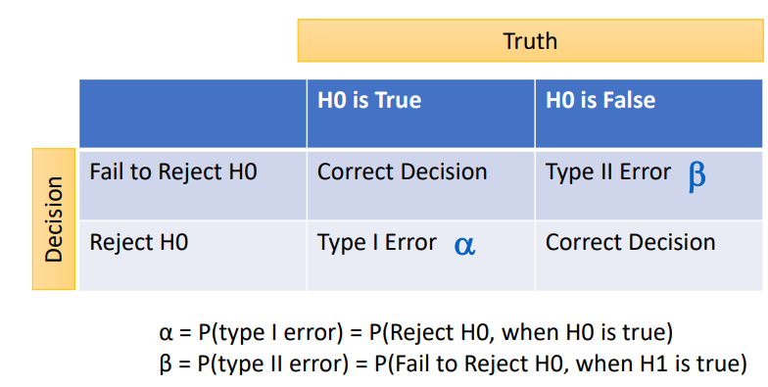
^the probability of a type I error is the significance level

For any fixed alpha, an increase in the sample size n will cause a decrease in beta.
For a fixed sample size, decreasing alpha will cause an increase in beta.

The power of a hypothesis test is the probability of rejecting a false null hypothesis. This is equal to (1 – beta) = P(reject H0 when H1 is true).

Graphs n shit:
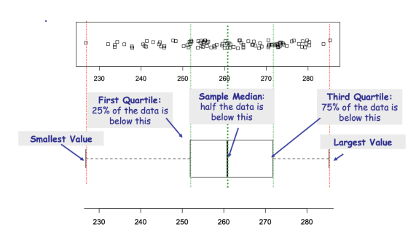
Box-whisker plot
Modified Box and Whisker plots exist that take outliers into account:

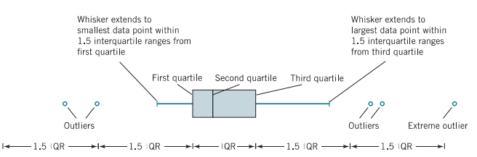
Time-Sequence Plots:
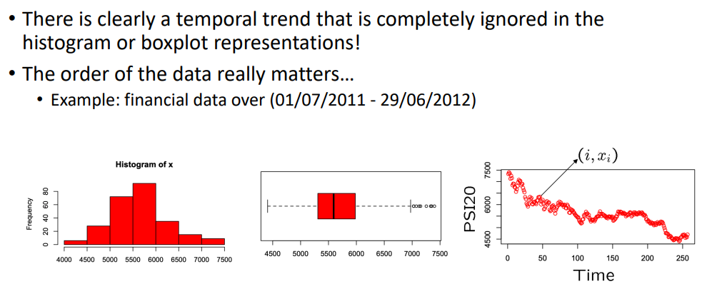
Quantile-Quantile Plots (QQ):
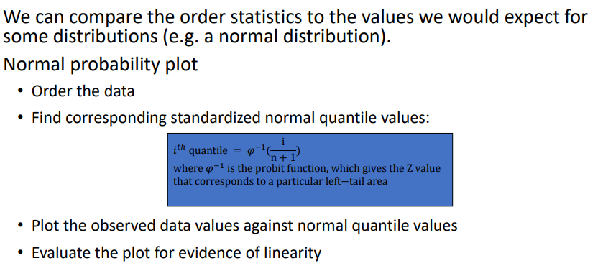
^ Normal QQ plots allow us to check whether data can be approximately modelled as a Normal distribution.

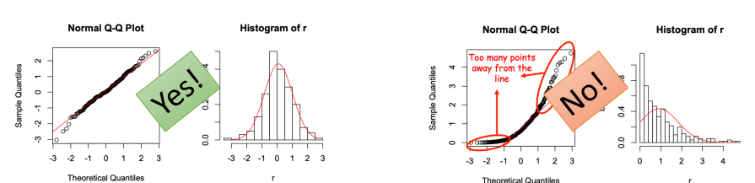
Scatter graph (omg) and correlation coefficients:

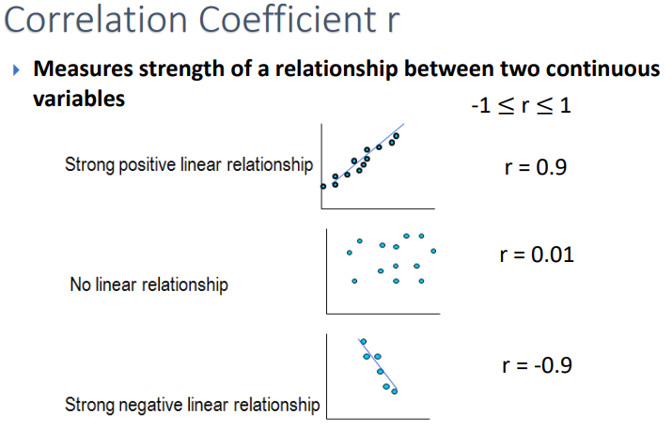
Choosing a distribution to model the data:
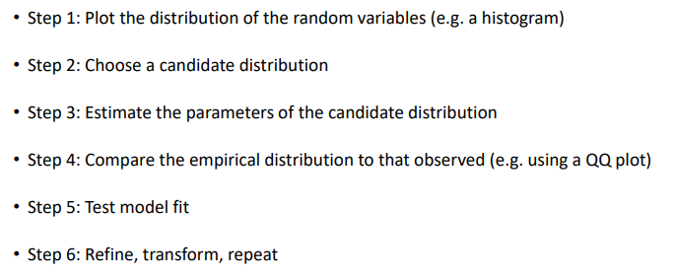
Data may need to be transformed to fit the model, e.g. log transformations and removal of outliers.
We can hypothesis test whether the model fits the data

